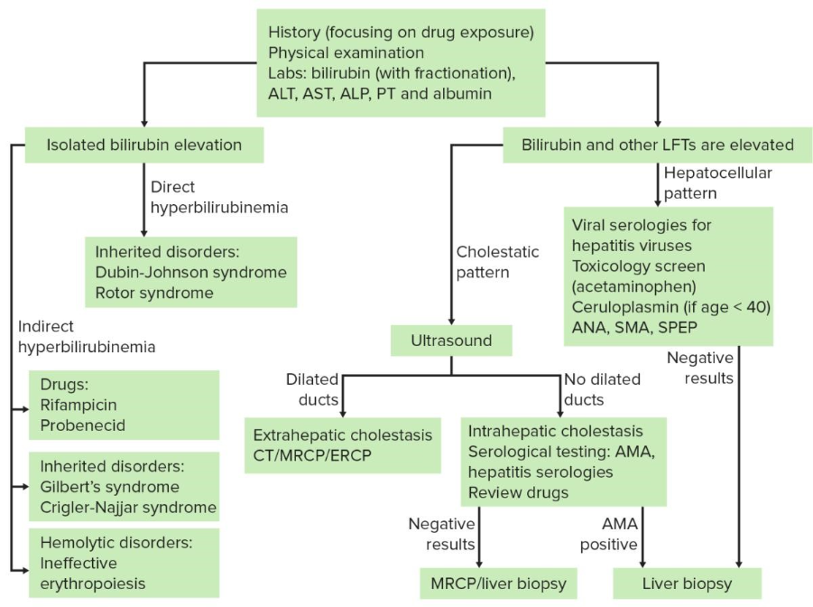
ANA, SMA, szérum ELFO – SLE, SS, Sjögren; AIH, PBC; MM
AMA – PBC, SS, Sjögren, SLE, AIH overlap
cöruloplazmin – Wilson kór

